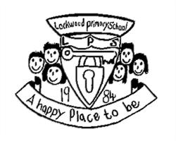banner with apples and crayons

# Attendance Award

The class with the best attendance last week was Mrs Walker’s Year 5 class with 99.8%.

They will have the attendance trophy in their classroom next week and have an additional afternoon playtime on Friday.

Most of the other classes had similar attendance figures, so well done to them too.

Can Mrs Walker’s class be beaten?

After School Club has now resumed and the children have had a fabulous week with Miss Watson and Mrs Fox. There are a variety of activities available to the children each night as well as a focused activity.

No child is ever made to participate in activities they are not comfortable with.  
Please see below the focus of next week’s activities:

|  |  |
| --- | --- |
| Monday | Boogie Night:  Zumba, Yoga, Dance. |
| Tuesday | Let’s get crafty!  Stone painting, leaf-rubbing and printing. |
| Wednesday | Sporty Night -  games and best of the best challenges |
| Thursday | Mystery Night! |

Lockwood Primary School Newsletter

Friday 25th September 2020

Hot school dinners will be available as of Monday 28th September. Menus can be found on the school website and on eschools.

Parents have the choice of ringing school to make us aware of their child’s menu choices or letting the children decide in school each day.

If your child is in Reception, Year 1 or Year 2 they are entitled to a school dinner without charge. Please consider this carefully as fewer packed lunches would help greatly reduce the amount your children are carrying to and from school each day, as well as reducing your workload.

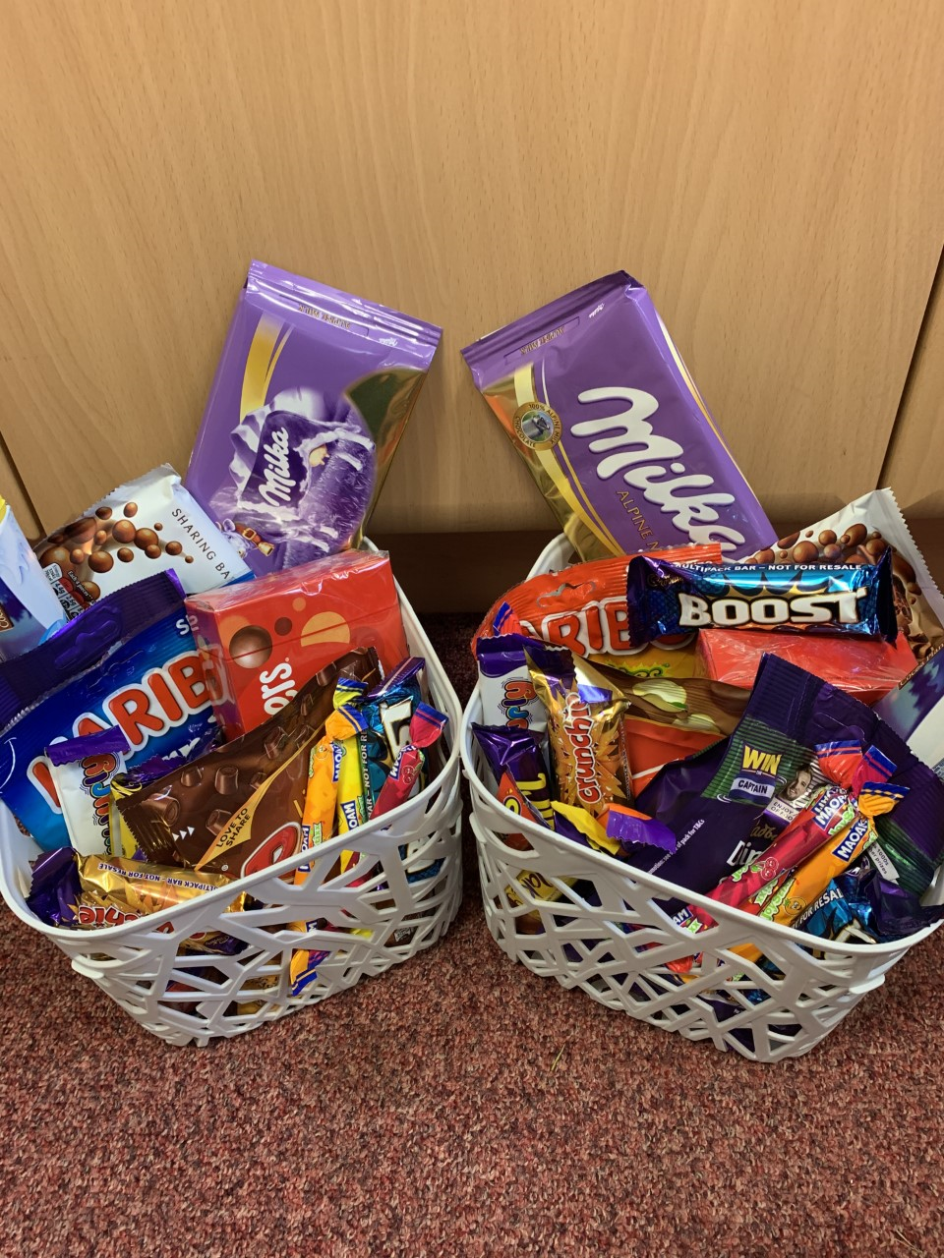

**After School Club**

Thank you for returning my technology questionnaire so promptly. I apologize for inciting a quick response with chocolate. As the head teacher of a healthy school, I promise to mend my ways and offer healthier incentives in the future.

# School Dinners

# Dear Parents/Carers

Have a lovely weekend. Mrs Lawson

# Resources Fundraising

Please have a little look on our website at our campaign to raise funds for more equipment in school, and share as far as you possibly can. The URL is <https://donatemyschool.com/lockwood-primary-school-2040>

I choose to try every day.

What will you choose?

I will be sending home consent forms next week.

The personal information (contact details) form is particularly important, for track and trace reasons.

The use of images consent will allow us to share the successes of your children such as ‘the best of the best’ award on our website and eschools.

By completing the educational visits consent you are agreeing to let your children participate in all of the lovely enrichment activities planned for the end of lock down in our locality.

We will contact the parents of any child flagged up as having a medical condition to complete a medical care plan. This will ensure we look after your child exactly as you wish.

Please take the time to read the consents, complete them and send them back to school, even if you do not wish to give consent.



This week our stars have been chosen because of their dedication to improving their reading skills.

**Reception:** Noah Bentley, Honey Hardy, James Bowden

**Year 1:** Maggie Johnson, Lilly Struwig, Jak Taylor

**Year 2:** Florence Crellin, Tommy Stonehouse, Nancy Bird

**Year 3:** Evie Brown, Evan Hood, Imogen Twiss

**Year 4:** Daniel Brek, Tayla Cane, Charlie Foster

**Year 5:** Corey Newlove, Ruby Spence, Molly Staines

**Year 6:** Charlie Passmore, Emily Raw, Owen Robinson

**Nursery:** Piper Frankland for listening and answering questions, Marcie Lewis for coming in with no tears, Harry Weldon for being polite and sensible.

## Consents

Lockwood Primary School Newsletter Page 2

.

# Best of the best awards: