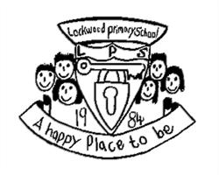Lockwood Newsletter

Friday 12th April 2024

**Dear Parents and Carers**

**Goodbye Ms Falconbridge**

We say goodbye to Ms Falconbridge on Wednesday,

I am sure you will join us in wishing her well. We will miss her.

**Rock Steady Concert**

We were blown away yesterday afternoon with our fabulous musicians at their Rock Steady concert. They work hard with Danni every Thursday. It was lovely to see so many parents and family were able to come and watch them perform, I am sure you really enjoyed it. The rest of the school enjoyed watching them.

If you want to sign your child up they should of brought home a flyer with the details on.



**Attendance**

Attendance this week is fantastic! Well done to Y6 who will receive an extra playtime one day next week.

Lets keep it up and see who can get 100% next week!

**Summer Fair**

We have a provisional date of Friday 7th June for our annual summer fair. Hopefully we can manage to book the weather this year! More details to follow.



**Dates for the Diary**

Monday 13th May – SATs week

Tuesday 7th – Friday 10th May – Y4 Swimming

Monday 13th May – Friday 17th May Y5 Swimming

Monday 20th May - Friday 24th May Y6 Swimming

Friday 24th May – Break up for 1 week

Monday 3rd June – Return to school

Friday 7th June – Summer Fair

**Headteacher’s Awards**

Reception: Reggie J

Year 1: Harrison

Year 2: Mila

Year 3: Kenny

Year 4: Presley

Year 5: Mikey

Year 6: Esme

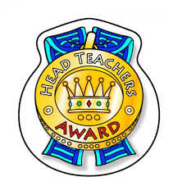

**Numbot awards**

Year 1: Paddy

Year 2: Harry W

**TTRS awards**  

Year 3: James

Year 4: Eppy

Year 5: Robert

Year 6: Esme

**Attendance**

Reception: 99%

Year 1: 96%

Year 2: 99%

Year 3: 98%

Year 4: 96%

Year 5: 97%

Year 6: 100%

Whole School: 98%