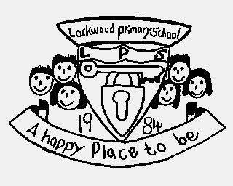

Lockwood Primary Reading Spine
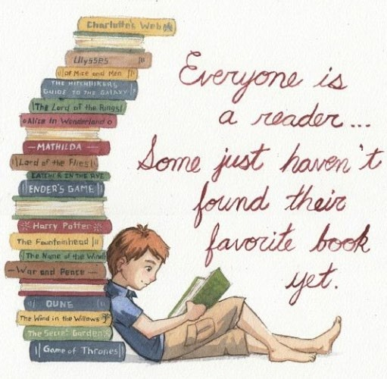
Bridging the gap between instruction and pleasure to create thinkers, believers and lifelong readers.

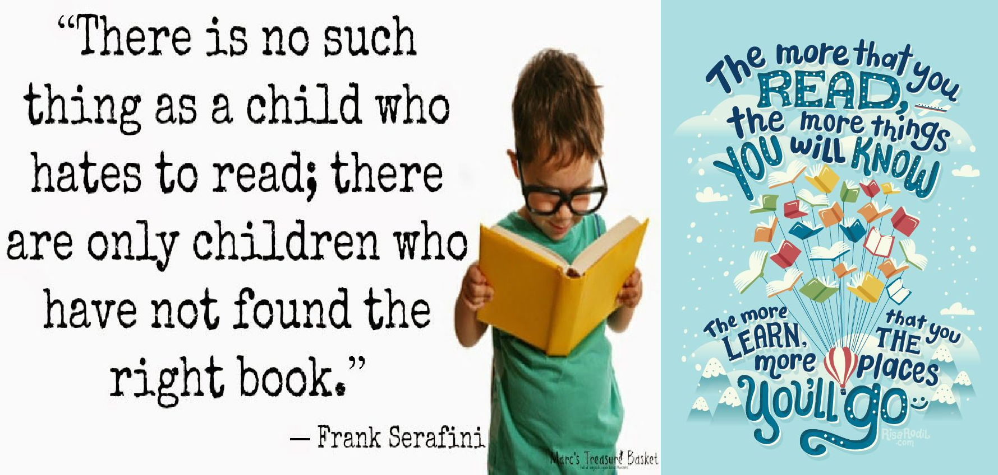
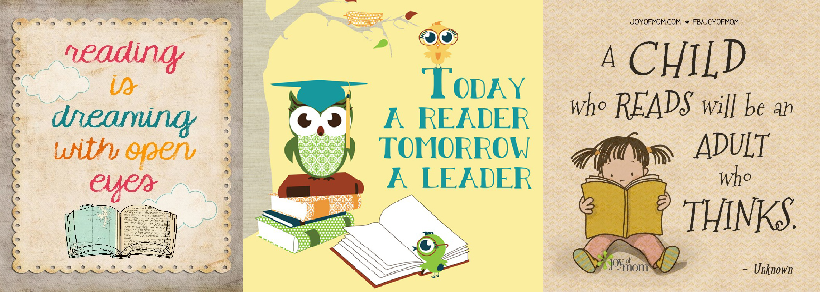

Our reading spine is a collection of recommended books which are considered to be ‘must-reads’ for everyone. The books in this collection consist of class core texts, recommended independent reads and class shared texts. Each book has been

Core texts rationale:
How have our texts been selected?

carefully chosen to stretch vocabulary, expose children to different structures and
timeframes, encourage critical and analytical thinking and promote a love of reading. Following this reading spine provides equality of opportunity for all children; ensuring all Lockwood pupils will leave school having had exposure to wide ranging, linguistically varied and intellectually stimulating collection of texts.

Exposure to a range of text types of various genres will gradually build children’s stamina and familiarity with challenging texts. It develops the skills they will need to dissect more complex texts at secondary school and enhances logic and problem solving abilities that can be applied in any scenario.
Instilling a love of reading to ensure that all children, even the most reluctant reader, have read and studied in depth, at least 6 quality texts each year. Where possible, these texts will link with the school’s overarching themes that run through each term; allowing children to make links and show clear progression through each Year group. Where quality texts do not directly link with a theme or a topic covered in foundation subjects, there will be a clear rationale for their selection, with an aim for drawing on links for current or previous themes, or links with other areas of the curriculum for that term. All class core texts will be used as a stimulus for writing lessons to ensure deep understanding of the text with contextual value to their writing.

Additional texts (Shared stories and independent reads) rationale:
These additional texts are based on research by Doug Lemov about ‘The Five Plagues of the Developing Reader’, which are the stumbling blocks children can face if they are not exposed to a rich variety of texts. The texts in our spine fall into these 5 categories:
Archaic Language – books which were (usually) written in the past and use vocabulary or sentence structures which we are unlikely to be exposed to in our everyday spoken language. Children need strategies to decode unfamiliar words and to build up their own bank of known archaic language.
Non-Linear Time Sequences – books which are not written chronologically. They may include flashbacks, time travel, multiple plots happening at different times or the start of the book being the end result. These books enable children to restructure the events chronologically in their mind as they read.
Narratively Complex – these texts are often told by a narrator who isn’t aware of everything which happens in a story or may have more than one narrator. These texts may also have plots which seem separate but then intertwine to pull the different plotlines together.
Figurative/Symbolic Text – books which use allegories, metaphors and symbols to represent an idea. For example, Jiminy Cricket represents a conscience in ‘Pinocchio’ and the snowman in the book ‘The Snowman’ is an allegory of death and grief.
Resistant Texts – books, and often poems, which deliberately try and create confusion. These texts should be viewed as a challenge or a brainteaser to try and work out the meaning. An example of this is ‘The Jabberwocky’ which uses nonsense words which meaning can be applied to.

In addition to these 5 plagues of the developing reader, we have also included a further category to reflect our diverse world:
Diversity – books which celebrate authors and protagonists that reflect our community and promote ethnical diversity.

These additional texts will be read throughout the year as either class shared stories or children’s independent reads. Our shared stories will be read by the teacher to promote Reading for Pleasure, ensuring all children hear stories, particularly for those children who have no reading role models at home. The class shared story is not to pick apart or analyse, but to share quality time where pupils enjoy being read to. “All classrooms, with pupils of any age, benefit from being read to. It exposes students to texts above their ability, models fluency and helps instill a love of reading…” (Doug Lemov)

EYFS: Nursery

In our Early Years Foundation Stage, children will have early exposure to our reading spine with a selection of carefully chosen class core texts, as well as a classroom reading areas stocked with additional texts consisting of a range of recommended reads.

Autumn 1  - Stories by Sue Hendra  - Simon sock, Dave, Cake and I need a wee  - Owl babies by Martin Waddell  - Peace at last by Jill Murphy  - Guess how much I love you by Sam McBratney  - Home is where the heart is by Lisa Alderson  - Love Monster stories by Rachel Bright  - Goldilocks and the three bears (traditional tale)  - Eat your greens Goldilocks by Steve Smallman | Autumn 2  - What’s in the witch’s kitchen by Nick Sharatt  - The Leaf thief by Alice Hemming  - Maisy mouse story collection by Lucy Cousins  - Dear Santa by Rod Campbell  - Kippers Christmas Eve by Mick Inkpen  - Oh no shark in the snow by Nick Sharatt
Spring 1  - Jack Frost by Kazuno Kohara  - Dear Zoo by Rod Campbell  - The three little pigs  - The three billy goats gruff  - Blue balloon (Maths week) | Spring 2  - Jasper’s Beanstalk by Nick Butterworth  - Fran’s flower by Lisa Bruce  - Titch by Pat Hutchins  - The orange dot by Jacob Widmann  - It’s not a box by Antoinette Portis  - The gingerbread man (traditional tale)  - The little yellow chick by Joy Cowley?  - We’re going on an egg hunt by Martha Mumford
Summer 1  - The very hungry caterpillar by Eric Carle  - Alien’s love underpants by  - Supertato  - Whatever next by Jill Murphy | Summer 2  - We’re going on a bear hunt by Michael Rosen  - The tiger who came to tea by Judith Kerr  - The train ride by  - Rosie goes to the seaside by June Crebbin  - Barry the fish with fingers by Sue Hendra  - Barry the fish with fingers and the hairy scary monster by Sue Hendra

EYFS: Reception

Autumn 1  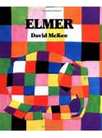Elmer David Mckee  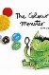The colour Monster Alan Lenas  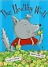The Healthy Wolf David Bedford  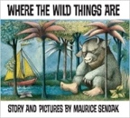  Where the Wild Things are By Maurice Sendak  Linked Learning: Difference | Autumn 2  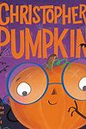Christopher Pumpkin Sue Hendra  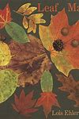Leaf man Lois Elhert  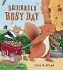Squirrel’s Busy Day by Lucy Barnard  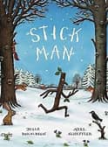Stick man Julia Donaldson  - The Nativity Story  - Divali Lighting a Lamp  - Remember, Remember the 5th of November Deborah Webb  Linked Learning: Celebrations & Autumnal Seasonal Changes
Spring 1  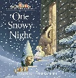One Snowy Night Nick Butterworth  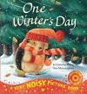One Winter’s Day Christina Butler  Lanterns and Firecrackers: a Chinese New Year Story  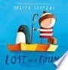Lost and Found Oliver Jeffers  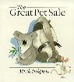The Great Pet Sale Nick Inkpen  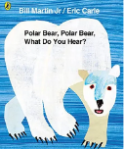Poetry- Polar Bear, Polar Bear what do you hear? Bill Martin  Linked Learning: celebrations, winter seasonal changes | Spring 2  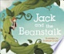Jack and the Beanstalk- anon  The Enormous Turnip  The Little Red Hen  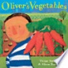Oliver’s Vegetables Alison Bartlett  A Seed In Need  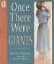Once there were Giants Martin Wardell  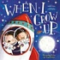When I grow Up John Hayles  Linked Learning: Spring seasonal changes, growth
Summer 1  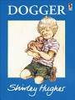Dogger Shirley Hughes  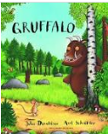Julia Donaldson – Author study:  The Gruffalo  The Smartest Giant in Town  A Squash and a Squeeze  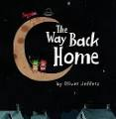The Way Back Home – Oliver Jeffers  Linked Learning: Toys in the past, Stories by the same author | Summer 2  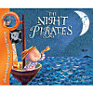The Night Pirates Peter Harris  Tiddler Julia Donaldson  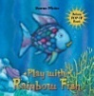The Rainbow Fish Marcus Pfister  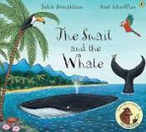The Snail and the Whale Julia Donaldson  The Life of a Little Plastic Bottle Igloo Books  Linked Learning: summer seasonal changes, environmental

EYFS: suggested Additional texts
Nursery |  | Reception
- Oi Get off Our Train - John Burningham  - Rabunzel - Gareth P. Jones  - We’re going on a lion hunt – David Axtell  - Maya in the Rubbish Sea - Lucy Munday  - The Squash and the Squeeze – Julia Dohnaldson  - On the way home – Jill Murphy  - Suddenly – Colin McNaughton  - This book just ate my dog - Richard Byrne  - I’m a feel – o – saur – Lezlie Evans  - I want my hat back – Jon Klassen  - Tough Guys Have Feelings Too - Keith Negley  - Big feelings - Alexandra Penfold | - I am a tiger - Karl Newson  - Stop that dinosaur - Alex English  - Jack and the Flum Flum tree – Julia Donaldson  - Julián Is a Mermaid - Jessica Love  - If All the World Were - Joseph Coelho  - Look Up! - Nathan Bryon and Dapo Adeola  - What if we were all the same - C.M Harris  - Shu Lin Grandpa - Matt Goodfellow  - I am enough - Grace Byers  - The Proudest Blue - Ibtihaj Muhammad  - The day you begin – Jacqueline Woodson | - Extra Yarn - Mac Barnett  - The Tiger who came to Tea- Judith Kerr  - Super Duper You! - Sophy Henn  - Love Monster - Rachel Bright  - Avocado Baby - John Burnigham  - The World Around Me - Charlotte Guillain  - The Pout-Pout Fish - Deborah Diesen  - Giraffes Can't Dance - Giles Andreae  - Lila and the Secret of Rain – David Conway  - Oh the things you can think – Dr Seuss  - Green eggs and Ham – Dr Seuss  - Aliens Love Underpants - Claire Freedman | - Matisse's Magical Trail – Tim Hopgood  - Just Like Me – Vanessa Newton  - Pink is for Boys – Pearlman Robb  - Bad Seed – John Jorry  - We Are Here – Oliver Jeffers  - Proudest Blue – S. K. Ali  - The Most Magnificent Thing - Ashley Spires  - The Story Tree: Tales to Read Aloud Book - Hugh Lupton  - Night Monkey, Day Monkey – Julia Donaldson  - Spinderella – Julia Donaldson  - Elmer the Patchwork Elephant - David McKee

KS1: Year 1
Autumn 1  Linked Learning: Journeys and exploration  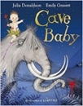  Cave Baby by Julia Donaldson & Emily Gravett  Labels and captions, character description. | Autumn 2  Linked Learning: Similarities and differences  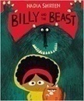  Billy and The Beast By Nadia Sharim  Wanted posters, narrative story writing.
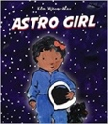  Astro Girl By Ken Wilson Max  Instructions, questions, non-fiction booklet. | 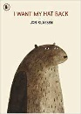  I want my Hat back By John Classon  Letter writing.
Story Time:
Traditional Tales- Little Red Riding Hood, Three Little Pigs, Gingerbread Man, The Three Billy Goats Gruff, including alternative versions (narratives from different viewpoints).

Spring 1  Linked Learning: Similarities and differences  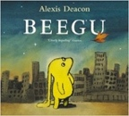  Beegu Alexis Deacon  Poetry, thought bubbles and speech bubbles. | Spring 2  Linked Learning: Nature and Environment  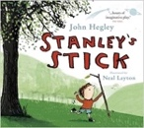  Stanley’s Stick By John Heagley and Neal Layton  Retellings and descriptions, own version narratives.
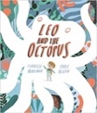  Leo and the Octopus By Isabelle Marionov  Factual descriptions, report. | 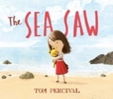  The Seesaw By Tom Percival  Diary entry recount.
Story Time:
Poetry- Space Poems
Roald Dahl – The Enormous Crocodile, Esio Trot.
Summer 1  Linked Learning: Friendship and kindness  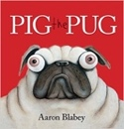  Pig the Pug by Aaron Blabey  How to guide (explanation), fact sheets,  Shared poetry. | Summer 2  Linked Learning: Imagination and creativity  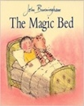  The Magic Bed John Burningham  Own version fantasy stories, setting descriptions, additional scenes, description of magical piece of furniture.
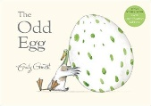  The Odd Egg By Emily Gravett  Egg spotters guides non-fiction reports, thoughts and speech bubbles. | 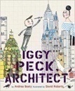  Iggy Peck Architect By Andrea Beatty and David Roberts  Character comparisons
Story Time:
The Tear Thief By Carol Ann Duffy & Cops and Robbers Janet and Alan Ahlberg

KS1: Year 2

Autumn 1  Linked Learning: Science Life Processes |  |  |  | Autumn 2  Citizenship & conservation
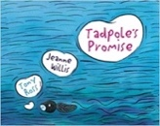  Tadpole’s Promise  Jeanne  Willis | 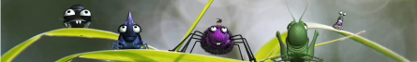  Caterpillar Shoes  Literacy Shed |  | 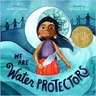  We Are Water Protectors  By Carole Lindstrom |  |  | Conservation animation and resources  Blue Planet
Explanation, five sentence retelling of the story, own version of a familiar story, dialogue between characters, character description |  |  | Poetry, Non-chronological reports, fact files, character description.
Spring 1  Bravery vs. fear |  |  |  | Spring 2  Change & Environment
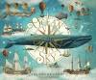 Where the Ocean meets the sky Eric Fan and the Fan Brothers | 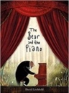  The Bear and the Piano  BY David Litchfield |  | 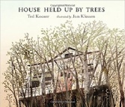  The House that was held up by Trees
Information brochure, letter writing with persuassion. | Narrative writing stories of bravery |  | News reports, instructions for seed packets, sequel narratives.
The Minpins  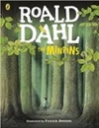  Roald Dahl |  |  | 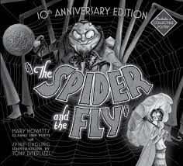  POETRY: The Spider and the Fly By Mary Howitt
Summer 1  Exploring change and relationships |  |  |  | Summer 2  Performance & Magic
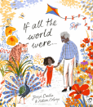  If all the world were  By Joseph Costello |  | 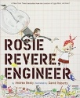  Rosie Revere: Engineer  Andrea Beatty | 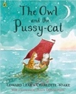  Poetry: The Owl and the Pussy-cat  Edward Lear |  | 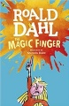  Transition Unit: Year 3  The Magic Finger : Roald Dahl
Non-narrative read aloud poem, writing in role, diary recount. |  | Leaflet for local landmarks. | Classic narrative poem, rhyming poems, calligrams, interviews, instructions
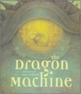  The Dragon Machine  Helen Ward |  |  |  | 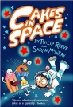  Cakes in Space: Philip Reeve

Throughout the year, the children will also have the opportunity to immerse themselves in a wide range of subject specific non-fiction books in order to appreciate information texts and deepen their understanding across the curriculum. These will be used as curriculum and writing stimulus and for Reading for enjoyment.

KS1: suggested Additional texts
 | Archaic Language | Non Linear Time  Sequences | Complexity of Narrator | Complexity of Plot | Resistant Texts | Diversity
Year 1 | The Ugly Duckling – Hans | Voices in the Park – Anthony | Hey Little Ant – Hannah Hoose | Wanted: The Perfect Pet – Fiona | Lost and Found – Oliver Jeffers | Sulwe by Lupita Nyong'o &
 | Christian Anderson | Browne | The Teddy Bear – David McPhail | Robertson | Wolves – Emily Gravett | Vashti Harrison
 | Where the Wild Things Are – | When the Rain Comes – Tom | The Day the Crayons Quit – Drew | The Heart and the Bottle – Oliver | Not Now Bernard – David McKee | Hair Love by Matthew Cherry &
 | Maurice Sendak | Pow | Daywalt | Jeffers |  | Vashti Harrison
 | Goodnight Moon – Margaret | Granpa – John Burningham | Fantastic Mr Fox – Roald Dahl |  |  | Happy in our skin – Fran
 | Wise Brown |  |  |  |  | Manushkin
 | The More it Snows – A A Milne
 | (poem)
Year 2 | The Magic Faraway Tree – Enid | The Trouble With Trolls – Jan | Chester – Melanie Watt | Grandad’s Island – Benji Davies | The Book With No Pictures – B.J. | We All Went On Safari - Laurie
 | Blyton | Brett | And the Dish Ran Away with the | Dinosaurs and All That Rubbish – | Novak | Krebs
 | The Tale of Peter Rabbit – Beatrix | Black and White – David | Spoon – Janet Stevens | Michael Foreman | Tadpole’s Promise – Jeanne Willis | Mommy’s Khimar - Jamilah
 | Potter | Macauley | The Wolf Story – What Really | The Red Tree – Shaun Tan | The Colour Monster – Anna | Thompkins-Bigelow
 | Aesop’s fables – Aesop | One Candle – Eve Bunting | Happened to Little Red Riding | The Chickens Build a Wall – Jean- | Llenas | So Much - Trish Cooke
 | The Owl and the Pussycat – | The Stinky Cheese Man – John | Hood – Toby Forward | Francois Dumont | Ning Nang Nong – Spike Milligan | Coming to England – Floella
 | Edward Lear | Scieska | The True Story of the Three Little | Red Kite, Blue Kite – Ji-Li Jiang | Mirror – Jeannie baker | Benjamin
 | The Frog Prince – Brothers Grimm | Three Brave Women – C.L.G | Pigs – John Scieska | The Building Boy – Ross | Window – Jeannie Baker | Antiracist baby – Ibram X. Kendi
 | The Night before Christmas – | Martin |  | Montgomery
 | Clement Clarke Moore | The Summer my Father Was Ten
 |  | – Pat Brisson

KS2: Year 3
Autumn term 1  Linked Learning: The Stone Age  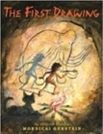  The First Drawing By Mordicai Gerstein  Historical Recount, diary entry, dialogue, character descriptions. | Autumn term 2  Linked Learning: Relationships  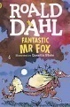Fantastic Mr Fox By Roald Dahl  Newspaper report, sequencing events, poem.
Reading Skills:  The Owl who was Afraid of the Dark By Jill Tomlinson  Novel Time:  The Owl who was Afraid of the Dark By Jill Tomlinson | Reading Skills:  Firework Maker’s Daughter By Phillip Pullman  Novel Time:  Fantastic Mr Fox By Roald Dahl
Spring 1  Linked Learning: Disaster, Hope and Healing  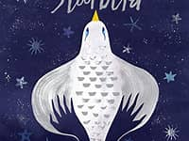Starbird By Carol King-Chai  Fables (own version), letter, dialogue,  post card.  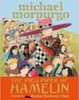  The Pied Piper of Hamelin By Michael Morpurgo  Persuasive adverts. | Spring 2  Linked Learning: Nature  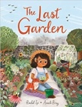  The Last Garden By Rachel Ip  Own version extended narrative, instructions with explanation.  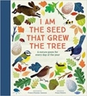  I am the Seed that Grew the Tree By Fiona Waters  Non-chronological report
Reading Skills:  James and the Giant Peach By Roald Dahl  Novel Time:  Magic and Mischief anthology Enid Blyton | Reading Skills:  New and Collected Poems for children By Carol Ann Duffy  Novel Time:  Empire’s End: A Roman Story By Leila Rasheed
Summer 1  Linked Learning: mystery and caution  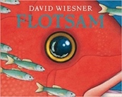  Flotsam By David Wiesner  Sequels (Mystery narratives), haiku, setting descriptions, letters (informal).  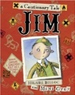  Jim, A cautionary Tale By Hilaire Belloc  Narrative poems, performance poetry. | Summer 2  Linked Learning: kindness  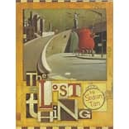The Lost Thing By Shaun Tann  Write and perform a play based on a familiar story, persuasive email, menu, brief prequel, descriptive setting (creating mood and atmosphere).
Reading Skills:  The Pied Piper of Hamelin By Robert Browning  Novel Time: Black Beauty By Anna Sewell | Reading Skills:  A Necklace of Raindrops By Joan Aiken  Novel Time:  Vlad the Drac by Ann Jungman

KS2: Year 4
Autumn term 1  Linked Learning: Coping with change  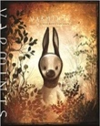  Varmints Helen Ward  Non-Chronological Report, character description  The Mermaid of Zenor Charles Causely  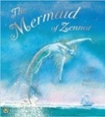  Own version legend, re-telling from a different perspective, dialogue. | Autumn term 2  Linked Learning: Relationships  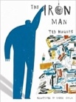  The Iron Man Ted Hughes  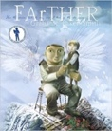  Newspaper report, character descriptions, letters of advice, menus.  FArTHER Grahame Baker Smith  Diary from the perspective of the boy
Novel Time: Cliff Hanger By Jacqueline Wilson | Novel Time: Roald Dahl The Twits
Spring 1  Linked Learning: Darkness and Light  The Selfish Giant Oscar Wilde  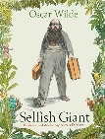Own version narratives about kindness, letters, poster.  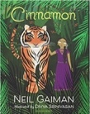  Cinnamon Neil Gaiman  Own version mythical tales, Dialogue, persuasive adverts, limericks and other poetic forms. | Spring 2  Linked Learning: Taking Courage  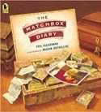  The Matchbox Diary Paul Fleishman  Biography, fact file.  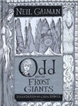  Odd and the Frost Giants Neil Gaiman  Re-tellings- alternative perspective, character and setting descriptions and short explanations.
Reading Skills:  The Selfish Giant Oscar Wilde  Novel Time:  My Dad’s a Birdman By David Almond | Reading Skills:  Odd and the Frost Giants Neil Gaiman  Novel Time:  Bill’s New Frock By Anne Fine  When Poems fall From the Sky By Zaro Weil
Summer 1  Linked Learning: Different Worlds  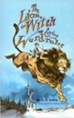  The Lion, the Witch and the Wardrobe, CS Lewis  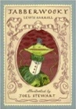  Narratives from other worlds, poems, eyewitness reports, writing in role.  Jabberwocky Lewis Carroll  Nonsense Poems, explanatory descriptions. | Summer 2  Linked Learning: Mother Nature  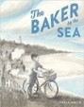The Baker by the Sea Paula White  Tourist Brochure, job applications, advertisements.  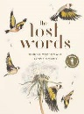The Lost Words Robert McFarlane  Narrative poems and free verse, descriptive writing.
Reading Skills: The Lion, The Witch and The Wardrobe CS Lewis  Novel Time: Pinocchio or The Butterfly Lion By Michael Morpurgo & When Poems fall From the Sky By Zaro Weil | Reading Skills and Novel Time:  Two Weeks with the Queen  Morris Gleitzman  When Poems fall From the Sky By Zaro Weil

KS2: Year 5
Autumn term 1  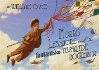 The Fantastic Flying Books of Mr Morris Lessmore, WE Joyce  Descriptive writing, free verse poetry.  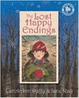  Lost Happy Endings by Carol Anne Duffy  writing from an alternative viewpoint, extended responses to a text, figurative poetry, Diary recount.  Linked Learning: Acts of Kindness | Autumn term 2  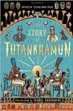  The Story of Tutankhamun By Patricia Cleveland-Peck  Tutankhamun Biographies  Reports, instructions, character descriptions, historical recounts.  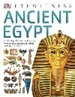  Linked Learning: Ancient Egypt
Reading Skills:  Alice In Wonderland Lewis Carrol  The Invisible Man By HG Wells  Novel Time:  Room 13 Robert Swindells | Reading Skills:  The Listeners By Walter De la Mer  Ancient Egypt By DK  Novel Time:  The Creakers by Tom Fletcher
Spring 1  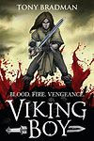Viking Boy By Tony Bradman  Newspaper report, Kennings, cinquains, Viking myths and sagas.  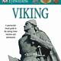  Linked Learning: Vikings | Spring 2  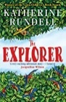Explorer By Katherine Rundell  Explanation of a geographical process, flashbacks, a balanced discussion presenting two sides of an argument after debate.  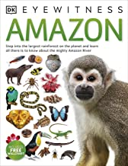  Linked Learning: Rainforests
Reading Skills& Novel Time  Viking Boy by Tony Bradman  Related texts- Vikings.  Novel Time:  Danny Champion of the World By Roald Dahl | Reading Skills:  Gonna Roll The Bones By David Weisner  Novel Time:  Explorer by Katherine Rundell
Summer 1  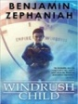  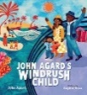Windrush Child: Benjamin Zephaniah  Windrush Child Poem by Paul Agar Persuasive pitch to the local council Thought bubble, informal letter, poem, advice, informal letter, Report- in form of information leaflet where two or more subjects are compared.  Linked Learning: Post WWII Britain – The Windrush Generation | Summer 2  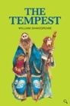  The Tempest W Shakespeare  Setting descriptions, character descriptions, soliloquy, instructional writing.  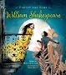  Linked Learning: performance
Reading Skills:  Black and British: A short, essential history  David Olusoga  Novel Time:  Windrush Child by Benjamin Zephaniah | Reading Skills:  On the Move: Poems about Migration Michael Rosen  Novel Time:  Poetry for Kids: William Shakespeare illustrated edition William Shakespeare
KS2: Year 6
Autumn term 1  Linked Learning: Linked to Ancient Maya  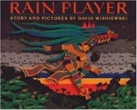  Rainplayer by David Wisniewski  Instructions, persuasive posters, essay writing (discursive), short narrative (dialogue). | Autumn term 2  Linked Learning: Remembrance  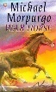War Horse Michael Morpurgo  Characterisation, diary, persuasive pamphlet (local pressure group)
Novel Time:  I know what you did last Wednesday? | Literary Leaf: Cosmic Frank Cottrell Boyce
Novel Time:
War Horse Michael Morpurgo
Spring 1  Linked Learning: Crime and Punishment  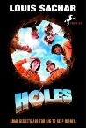Holes By Louis Sachar  Setting description, Narrative (with dialogue), Non-chronological report.  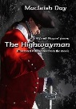The Highway Man Alfred Noyes, diary, free verse poetry | Spring 2  Linked Learning: Mystery and Wonder  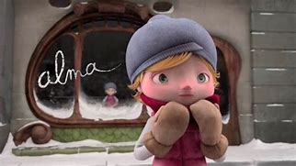Alma Literacy Shed  Suspense narrative (5 part narrative building atmosphere)  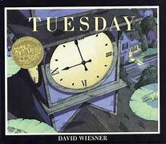Tuesday David Weisner  Diary entry (different levels of formality)  Journalistic writing.
Literary Leaf:  Boy in the Tower Polly Ho Yin | Reading Skills Recap: All Domains, connecting previous reading experiences.
Novel Time:  Holes By Louis Sachar | Novel Time:  Boy in the Tower Polly Ho Yin
Summer 1  Linked Learning: Science Evolution  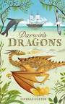Darwin’s Dragons Lyndsey Galvin  Encyclopaedia extract, Biography (leading to Transition writing- autobiography) | Summer 2  Linked Learning: KS3 Transition  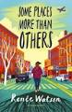Some Places More than Others By Renee Watson  Summaries, poems with similar structures, analysis and performances.
Literary Leaf Reading Skills:  Poetry for kids- William Shakespeare  Novel Time:  Transition Text: Can you see me? Libby Scott | Literary Leaf Reading Skills:  Some Places More than Others By Renee Watson  Novel Time:  Transition Text: Can you see me? Libby Scott

During the course of the year, each class will have the opportunity to dive into a range of non-fiction texts related to their unit of study throughout the curriculum; including science, history and geography. These will be used to across a range of subject and writing stimulus. The following texts are in addition to the above and will be available to children through independent reading or class story.

KS2: Additional texts
 | Archaic Language | Non Linear Time Sequences | Complexity of Narrator | Complexity of Plot | Resistant Texts | Diversity
Year 3 | The Queen’s Nose – Dick King- Smith  Charlotte’s Web – E.B. White The Children of Green Knowe – Lucy M. Boston  Pippi Longstocking – Astrid Lindgren | The Midnight Fox – Betsy Byers The Legend of Captain Crow’s Teeth – Eoin Colfer  The Firework Maker’s Daughter – Phillip Pullman | The Legend of Podkin One-Ear – Keiran Larwood  The Creakers – Tom Fletcher | Revolting Rhymes – Roald Dahl The Tunnel – Anthony Browne Stig of the Dump – Clive King | The Mysteries of Harris Burdick – Cris Van Allsburg  Topsy Turvy World (poem) – William Brightly Rands  The Great Panjandrum Himself – Samuel Foote  Bananas in my Ear – Michael Rosen | Planet Omar – Zainab Mian  Sam Wu Is NOT Afraid of Ghosts! – Katie & Kevin Tsang  Ellie & the Cat – Malorie Blackman Mayhem Mission – Burhana Islam
Year 4 | Five Children and It – Edith Nesbitt  Just William – Richmal Compton The Lion, The Witch and the Wardrobe – C.S. Lewis  Alice’s Adverntures in Wonderland – Lewis Carroll The Little Match Girl – Hans Christian Anderson | Clockwork – Phillip Pullman Harry Potter and the Philosopher’s Stone– JK Rowling Farm Boy – Michael Morpurgo | I am rat – Phillip Pullman The miraculous journey of Edward Tulane – Kate DiCamillo  Varjack Paw – S.F.Said | Artemis Fowl – Eoin Colfer Demon Dentist - David Walliams The Iron Woman – Ted Hughes The Train to impossible places –  P.G. Bell | Cloud Busting – Malorie Blackman The Walrus and the Carpenter – Lewis carroll  Where Zebras Go – Sue-Hardy Dawson | Little Badman – Henry White & Humza Arshad  Gregory Cool – Caroline Binch Anisha: Accidental detective – Serena Patel
Year 5 | Tom’s Midnight Garden – Phillipa Pearce  The Secret Garden – Frances Hodgeson Burnett  The Jungle Book – Rudyard Kipling | A Christmas Carol – Charles Dickens  The Eagle in the Snow – Michael Morpurgo  The Time Travelling Hamster – Ross Welford  The London Eye Mystery - Siobhan Dowd | A series of Unfortunate Events – Lemony Snickett  Cogheart – Peter Bunzl Kensuke’s Kingdom - Michael Morpurgo  Boy in the Tower - Polly Ho-Yen | Northern Lights – Phillip Pullman Swallows and Amazons – Arthur Ransome  Harry Potter and the Goblet of Fire– JK Rowling  Welcome to Nowhere - Elizabeth Laird  Rooftoppers- Katherine Rundell | The Arrival – Shaun Tan  The Pobble Who had no Toes (poem) – Edward Lear  Sky in the Pie (poem) – Roger McGough | Journey to Jo’burg - Beverley Naidoo Blackberry Blue and Other Fairy Tales  - Jamila Gavin  A Victorian Story – E.L. Norry The Infinite – Patience Agbabi The Breadwinner – Deborah Ellis
Year 6 | The Hobbit – J.R.R. Tolkien White Fang – Jack London Journey to the Centre of the Earth – Jules Verne  Oliver Twist – Charles Dickens Macbeth – Abridged | Holes – Louis Sachar  The Infinite Lives of Maisie May – Christopher Edge  The Boy in The Striped Pyjamas – John Boyne | Warhorse – Michael Morpurgo Once – Morris Gleitzman Watership Down – Richard Adams  A boy called Hope - Lara Williamson | The Lady of Shalott – Alfred, Lord Tennyson  In Flanders Fields (poem) – John McCrae  Floodland - Marcus Sedgewick The House with Chicken Legs - Sophie Anderson  Harry Potter and the Deathly Hallows – J.K. Rowling | A Monster Calls – Patrick Ness The Tyger (poem) – William Blake Jabberwocky (poem) – Lewis carroll | The Girl Who Stole and Elephant – Nizrana Farook  High Rise Mystery – Sharna Jackson Now or Never: A Dunkirk Story – Bali Rai  A Pocket Full of Stars – Aisha Bushby Henry’s Freedom Box – Ellen Levine Harriet Tubman – Sandra A. Agard

