Teaching through a text: Texts and writing genres Year 3 Overview
Autumn term 1  Linked Learning: The Stone Age  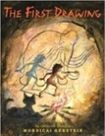  The First Drawing By Mordicai Gerstein  Historical Recount, diary entry, dialogue, character descriptions. | Autumn term 2  Linked Learning: Relationships  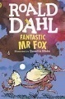Fantastic Mr Fox By Roald Dahl  Newspaper report, sequencing events, poem.
Reading Skills:  The Owl who was Afraid of the Dark By Jill Tomlinson  Novel Time:  The Owl who was Afraid of the Dark By Jill Tomlinson | Reading Skills:  Firework Maker’s Daughter By Phillip Pullman  Novel Time:  Fantastic Mr Fox By Roald Dahl
Spring 1  Linked Learning: Disaster, Hope and Healing  Starbird By Carol King-Chai  Fables (own version), letter, dialogue,  post card.  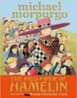  The Pied Piper of Hamelin By Michael Morpurgo  Persuasive adverts. | Spring 2  Linked Learning: Nature  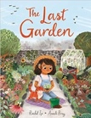  The Last Garden By Rachel Ip  Own version extended narrative, instructions with explanation.  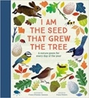  I am the Seed that Grew the Tree By Fiona Waters  Non-chronological report
Reading Skills:  James and the Giant Peach By Roald Dahl  Novel Time:  Magic and Mischief anthology Enid Blyton | Reading Skills:  New and Collected Poems for children By Carol Ann Duffy  Novel Time:  Empire’s End: A Roman Story By Leila Rasheed
Summer 1  Linked Learning: mystery and caution  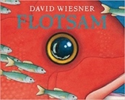  Flotsam By David Wiesner  Sequels (Mystery narratives), haiku, setting descriptions, letters (informal).  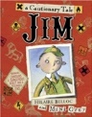  Jim, A cautionary Tale By Hilaire Belloc  Narrative poems, performance poetry. | Summer 2  Linked Learning: kindness  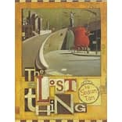The Lost Thing By Shaun Tann  Write and perform a play based on a familiar story, persuasive email, menu, brief prequel, descriptive setting (creating mood and atmosphere).
Reading Skills:  The Pied Piper of Hamelin By Robert Browning  Novel Time: Black Beauty By Anna Sewell | Reading Skills:  A Necklace of Raindrops By Joan Aiken  Novel Time:  Vlad the Drac by Ann Jungman

