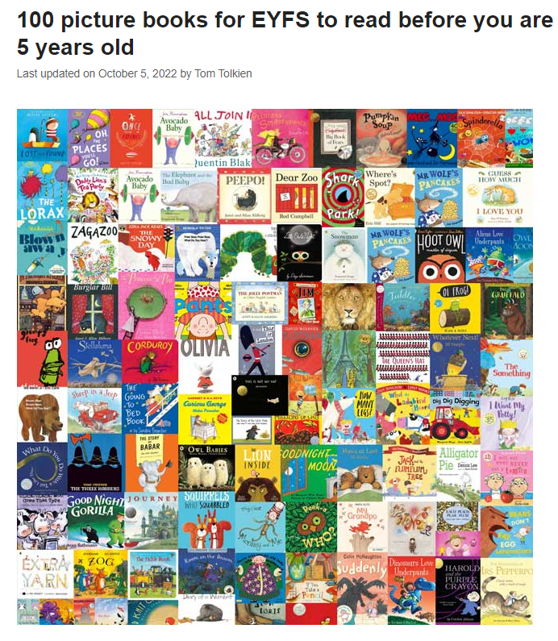

[Books for EYFS | 100 picture books to read before you are 5 years old (schoolreadinglist.co.uk)](https://schoolreadinglist.co.uk/reading-lists-for-ks1-school-pupils/100-best-picture-books-to-read-before-you-are-5-years-old/)

For more details, go to:

[Books for EYFS | 100 picture books to read before you are 5 years old (schoolreadinglist.co.uk)](https://schoolreadinglist.co.uk/reading-lists-for-ks1-school-pupils/100-best-picture-books-to-read-before-you-are-5-years-old/)