Teaching through a text: Texts and writing genres Year 6 Overview
Autumn term 1  Linked Learning: Linked to Ancient Maya  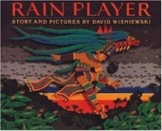  Rainplayer by David Wisniewski  Instructions, persuasive posters, essay writing (discursive), short narrative (dialogue). | Autumn term 2  Linked Learning: Remembrance  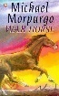War Horse Michael Morpurgo  Characterisation, diary, persuasive pamphlet (local pressure group)
Novel Time:  I know what you did last Wednesday? | Literary Leaf: Cosmic Frank Cottrell Boyce
Novel Time:
War Horse Michael Morpurgo
Spring 1  Linked Learning: Crime and Punishment  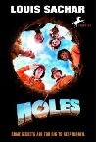Holes By Louis Sachar  Setting description, Narrative (with dialogue), Non-chronological report.  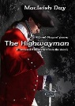The Highway Man Alfred Noyes, diary, free verse poetry | Spring 2  Linked Learning: Mystery and Wonder  Alma Literacy Shed  Suspense narrative (5 part narrative building atmosphere)  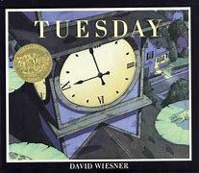Tuesday David Weisner  Diary entry (different levels of formality)  Journalistic writing.
Literary Leaf:  Boy in the Tower Polly Ho Yin | Reading Skills Recap: All Domains, connecting previous reading experiences.
Novel Time:  Holes By Louis Sachar | Novel Time:  Boy in the Tower Polly Ho Yin
Summer 1  Linked Learning: Science Evolution  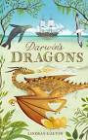Darwin’s Dragons Lyndsey Galvin  Encyclopaedia extract, Biography (leading to Transition writing- autobiography) | Summer 2  Linked Learning: KS3 Transition  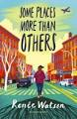Some Places More than Others By Renee Watson  Summaries, poems with similar structures, analysis and performances.
Literary Leaf Reading Skills:  Poetry for kids- William Shakespeare  Novel Time:  Transition Text: Can you see me? Libby Scott | Literary Leaf Reading Skills:  Some Places More than Others By Renee Watson  Novel Time:  Transition Text: Can you see me? Libby Scott

