Autumn term 1  Linked Learning: Coping with change  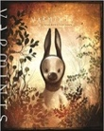  Varmints Helen Ward  Non-Chronological Report, character description  The Mermaid of Zenor Charles Causely  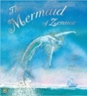  Own version legend, re-telling from a different perspective, dialogue. | Autumn term 2  Linked Learning: Relationships  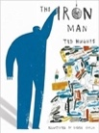  The Iron Man Ted Hughes  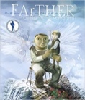  Newspaper report, character descriptions, letters of advice, menus.  FArTHER Grahame Baker Smith  Diary from the perspective of the boy
Novel Time: Cliff Hanger By Jacqueline Wilson | Novel Time: Roald Dahl The Twits
Spring 1  Linked Learning: Darkness and Light  The Selfish Giant Oscar Wilde  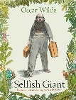Own version narratives about kindness, letters, poster.  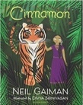  Cinnamon Neil Gaiman  Own version mythical tales, Dialogue, persuasive adverts, limericks and other poetic forms. | Spring 2  Linked Learning: Taking Courage  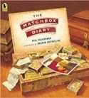  The Matchbox Diary Paul Fleishman  Biography, fact file.  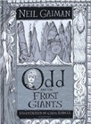  Odd and the Frost Giants Neil Gaiman  Re-tellings- alternative perspective, character and setting descriptions and short explanations.
Reading Skills:  The Selfish Giant Oscar Wilde  Novel Time:  My Dad’s a Birdman By David Almond | Reading Skills:  Odd and the Frost Giants Neil Gaiman  Novel Time:  Bill’s New Frock By Anne Fine  When Poems fall From the Sky By Zaro Weil
Summer 1  Linked Learning: Different Worlds  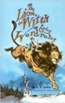  The Lion, the Witch and the Wardrobe, CS Lewis  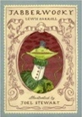  Narratives from other worlds, poems, eyewitness reports, writing in role.  Jabberwocky Lewis Carroll  Nonsense Poems, explanatory descriptions. | Summer 2  Linked Learning: Mother Nature  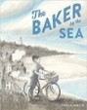The Baker by the Sea Paula White  Tourist Brochure, job applications, advertisements.  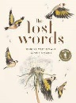The Lost Words Robert McFarlane  Narrative poems and free verse, descriptive writing.
Reading Skills: The Lion, The Witch and The Wardrobe CS Lewis  Novel Time: Pinocchio or The Butterfly Lion By Michael Morpurgo & When Poems fall From the Sky By Zaro Weil | Reading Skills and Novel Time:  Two Weeks with the Queen  Morris Gleitzman  When Poems fall From the Sky By Zaro Weil

