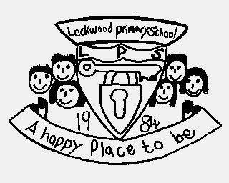 **Lockwood Primary School Writing ‘Take Aways’**

|  |  |  |  |
| --- | --- | --- | --- |
| Year group | By the end of the **autumn** term all children should be able to… | By the end of the **spring** term all children should be able to… | By the end of the **summer** term all children should be able to… |
| EYFS | Talk a simple sentence. | Talk grammatically correct simple sentences. | Write a simple sentence ending with a full stop. |
| Year 1 | Write a sequence of simple sentences ending with a full stop.  Use the past and present tense correctly when speaking and writing. | Write a sequence of simple sentences beginning with a capital letter and ending with a full stop. | Write sentences embellished by using simple adjectives, beginning with a capital letter and ending with a full stop. |
| Year 2 | Write sentences embellished by using simple adjectives, beginning with a capital letter and ending with a full stop.  Link sentences using conjunctions (and, so). | Use conjunctions to create compound sentences (because, but, until).  Include the use of commas in a list for description. | Write correctly punctuated sentences (both simple and compound) embellished by using adjectives. |
| Year 3 | Write correctly punctuated sentences (both simple and compound) embellished by using adjectives and adverbs. | Use adverbs to add detail to sentence openings. | Group together ideas in paragraphs.  Use subheadings to organise paragraphs around a theme. |
| Year 4 | Use fronted adverbials to add detail to sentence openings.  Write clearly defined paragraphs around a theme. | Use inverted commas to punctuate direct speech.  Ensure text is written in a consistent/appropriate tense. | Use a comma to demarcate fronted adverbials/adverbial starters for sentence openings. |
| Year 5 | Use a variety of sentence structures e.g. simple, long/short and multi-clause using a range of devices. | Integrate dialogue into narratives with correct speech punctuation. | Use relative clauses (embedded clause) beginning with who, which, when, where, that, whose, whom and punctuate using a comma. |
| Year 6 | Use a variety of correctly punctuated sentence structures e.g. simple, long/short, multi-clause and embedded clauses using a range of devices. | Link ideas across paragraphs using a wide range of cohesive devices. | Use a range of techniques to involve the reader; comments, questions, observations. |