Autumn 1  Linked Learning: Science Life Processes |  |  |  | Autumn 2  Citizenship & conservation
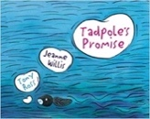  Tadpole’s Promise  Jeanne  Willis | 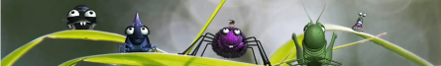  Caterpillar Shoes  Literacy Shed |  | 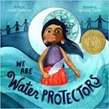  We Are Water Protectors  By Carole Lindstrom |  |  | Conservation animation and resources  Blue Planet
Explanation, five sentence retelling of the story, own version of a familiar story, dialogue between characters, character description |  |  | Poetry, Non-chronological reports, fact files, character description.
Spring 1  Bravery vs. fear |  |  |  | Spring 2  Change & Environment
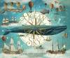 Where the Ocean meets the sky Eric Fan and the Fan Brothers | 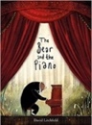  The Bear and the Piano  BY David Litchfield |  | 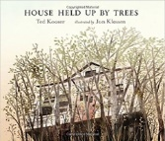  The House that was held up by Trees
Information brochure, letter writing with persuassion. | Narrative writing stories of bravery |  | News reports, instructions for seed packets, sequel narratives.
The Minpins  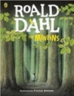  Roald Dahl |  |  | 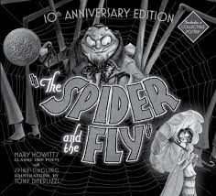  POETRY: The Spider and the Fly By Mary Howitt
Summer 1  Exploring change and relationships |  |  |  | Summer 2  Performance & Magic
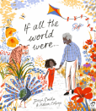  If all the world were  By Joseph Costello |  | 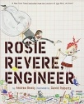  Rosie Revere: Engineer  Andrea Beatty | 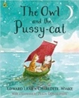  Poetry: The Owl and the Pussy-cat  Edward Lear |  | 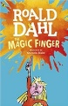  Transition Unit: Year 3  The Magic Finger : Roald Dahl
Non-narrative read aloud poem, writing in role, diary recount. |  | Leaflet for local landmarks. | Classic narrative poem, rhyming poems, calligrams, interviews, instructions
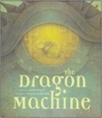  The Dragon Machine  Helen Ward |  |  |  | 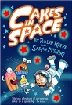  Cakes in Space: Philip Reeve

