Teaching through a text: Texts and writing genres Year 5 Overview

Autumn term 1  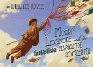 The Fantastic Flying Books of Mr Morris Lessmore, WE Joyce  Descriptive writing, free verse poetry.  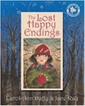  Lost Happy Endings by Carol Anne Duffy  writing from an alternative viewpoint, extended responses to a text, figurative poetry, Diary recount.  Linked Learning: Acts of Kindness | Autumn term 2  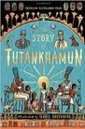  The Story of Tutankhamun By Patricia Cleveland-Peck  Tutankhamun Biographies  Reports, instructions, character descriptions, historical recounts.  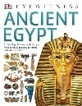  Linked Learning: Ancient Egypt
Reading Skills:  Alice In Wonderland Lewis Carrol  The Invisible Man By HG Wells  Novel Time:  Room 13 Robert Swindells | Reading Skills:  The Listeners By Walter De la Mer  Ancient Egypt By DK  Novel Time:  The Creakers by Tom Fletcher
Spring 1  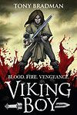Viking Boy By Tony Bradman  Newspaper report, Kennings, cinquains, Viking myths and sagas.  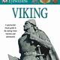  Linked Learning: Vikings | Spring 2  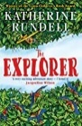Explorer By Katherine Rundell  Explanation of a geographical process, flashbacks, a balanced discussion presenting two sides of an argument after debate.  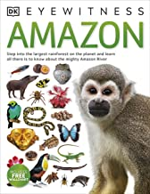  Linked Learning: Rainforests
Reading Skills& Novel Time  Viking Boy by Tony Bradman  Related texts- Vikings.  Novel Time:  Danny Champion of the World By Roald Dahl | Reading Skills:  Gonna Roll The Bones By David Weisner  Novel Time:  Explorer by Katherine Rundell
Summer 1  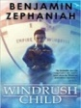  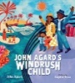Windrush Child: Benjamin Zephaniah  Windrush Child Poem by Paul Agar Persuasive pitch to the local council Thought bubble, informal letter, poem, advice, informal letter, Report- in form of information leaflet where two or more subjects are compared.  Linked Learning: Post WWII Britain – The Windrush Generation | Summer 2  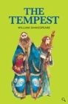  The Tempest W Shakespeare  Setting descriptions, character descriptions, soliloquy, instructional writing.  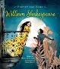  Linked Learning: performance
Reading Skills:  Black and British: A short, essential history  David Olusoga  Novel Time:  Windrush Child by Benjamin Zephaniah | Reading Skills:  On the Move: Poems about Migration Michael Rosen  Novel Time:  Poetry for Kids: William Shakespeare illustrated edition William Shakespeare

