Reception | Outside Inside Autumn 1 |  |  |  |  |  |  |  |  |  | Autumnal Changes Autumn 2
Planning Sequence | 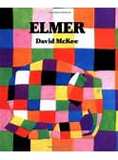 Elmer David McKee |  | The Colour Monster  Alan Lenas |  |  | 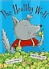The Healthy Wolf  David Bedford |  |  | 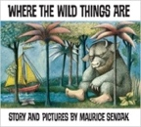  Where the Wild Things Are  Maurice Sendak | 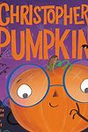Christopher Pumpkin Sue Hendra |  | 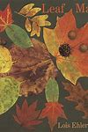Leaf Ma Lois Elhert |  |  | 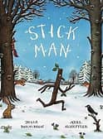 Stickman Julia Donaldson |  |  | 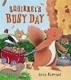Squirrel’s Busy Day  Lucy Barnard |  | National Nursery Rhyme week – EYFS  See set list
Theme/Term | Celebrations and Seasons Spring 1 |  |  |  |  |  |  |  |  |  | Sowing a seed / growth Spring 2
Planning Sequence | One Snowy Night By Nick Butterworth | The Great Pet Sale By Nick Inkpen | 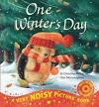One Winter’s Day By Christina Butler |  |  | Poetry: Polar Bear, Polar Bear what do you Hear? Bill Martin |  | 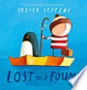Lost and Found Oliver Jeffers |  | 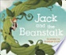Jack and the Beanstalk,The Enormous Turnip, Little Red Hen |  | 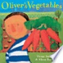Oliver’s Vegetables By Alison Bartlett |  |  | 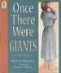Once there were Giants By Martin Wardell |  |  |  | 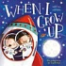When I grow up:John Hayles
Theme/Term | Toys in the past/ stories by the same author Summer 1 |  |  |  |  |  |  |  |  |  | Environment Summer 2
Planning Sequence | 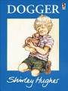Dogger By Shirley Hughes |  | Julia Donaldson author study: The Gruffalo, The Smartest Giant in Town, A Squash and a Squeeze |  |  |  | 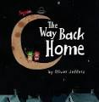Oliver Jeffers: The Way Back Home |  |  | 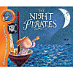Peter Harris: The Night Pirates |  | Julia Donaldson:  Tiddler  The Snail and the Whale |  |  | 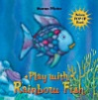Marcus Pfister: The Rainbow Fish |  |  |  | The Life of a Plastic Bottle: Igloo Books
Year 1 | Journeys & exploration Autumn 1 |  |  |  |  |  |  |  |  |  | Heroes & villains Autumn 2
Planning Sequence/  Spelling Seed Text | 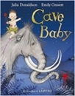  Cave Baby  Julia Donaldson and Emily Gravett |  | 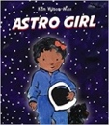  Astro Girl  Ken Wilson-Max |  |  |  |  |  |  |  | 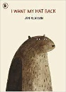  I Want My Hat Back  Jon Klassen | 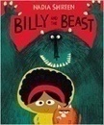  Billy and the Beast  Nadia Shireen
Theme/Term | Similarities & differences Spring 1 |  |  |  |  |  |  |  |  |  | Nature & environment Spring 2
Planning Sequence/  Spelling Seed Text | 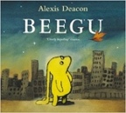  Beegu  Alexis Deacon |  |  | 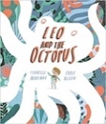  Leo and the Octopus  Isabelle Marinov |  |  |  |  |  | 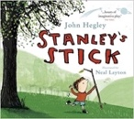  Stanley’s Stick  John Hegley and Neal Layton |  | 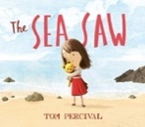  The Sea Saw  Tom Percival
Theme/Term | Friendship & kindness Summer 1 |  |  |  |  |  |  |  |  |  | Imagination & creativity Summer 2
Planning Sequence/  Spelling Seed Text | 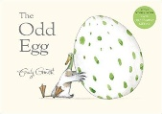  The Odd Egg By Emily Gravett |  | 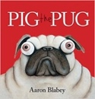  Pig the Pug  Aaron Blabey and  How to be a Dog  Jo Williamson |  |  |  |  |  |  | 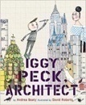  Iggy Peck, Architect  Andrea Beatty and David Roberts |  | 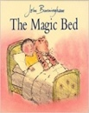  The Magic Bed  John Burningham
Year 2 | A twist in the tale Autumn 1 |  |  |  |  |  |  |  |  |  | Creation & conservation Autumn 2
Planning Sequence/  Spelling Seed Text | 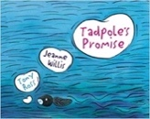  Tadpole’s Promise  Jeanne Willis |  | 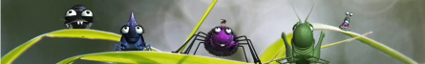  Caterpillar Shoes  Literacy Shed |  |  |  |  |  |  | 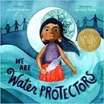  We Are Water Protectors  Carole Lindstrom |  |  |  | Conservation animation and resources  Blue Planet
Theme/Term | Bravery vs. fear Spring 1 |  |  |  |  |  |  |  |  |  | Change & Environment Spring 2
Planning Sequence/  Spelling Seed Text | 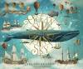 Where the Ocean meets the sky  Eric Fan and the Fan Brothers |  | 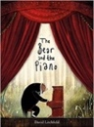  The Bear and the Piano  David Litchfield |  |  |  |  |  |  | 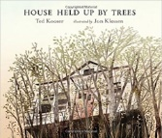  The House that was held up by Trees
Literary Leaf Text | The Minpins  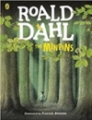  Roald Dahl |  |  |  |  |  |  |  |  | 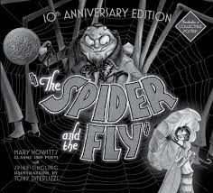  POETRY: The Spider and the Fly By Mary Howitt
Theme/Term | Exploring change and relationships Summer 1 |  |  |  |  |  |  |  |  |  | Urban metropolis Summer 2
Planning Sequence/  Spelling Seed Text | 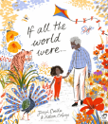  If all the world were By Joseph Costello |  |  |  | 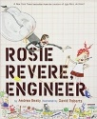  Rosie Revere: Engineer  Andrea Beatty |  |  |  |  | 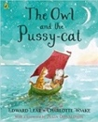  Poetry: The Owl and the Pussy-cat  Edward Lear |  |  | 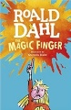  Transition Unit: Year 3  The Magic Finger : Roald Dahl
Literary Leaf Text | 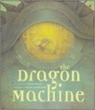  The Dragon Machine  Helen Ward |  |  |  |  |  |  |  |  |  | 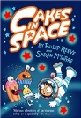  Cakes in Space: Philip Reeve
Year 3 | Magic & wonder Autumn 1 |  |  |  |  |  |  |  |  |  | Dreams & curiosity Autumn 2
Planning Sequence/  Spelling Seed Text | 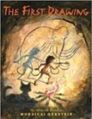  The First Drawing  Mordicai Gerstein |  |  |  |  |  |  |  |  |  | 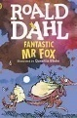Fantastic Mr Fox Roald Dahl
Literary Leaf Text | 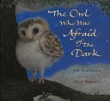 The Owl who was afraid of the dark Jill Tomlinson |  |  |  |  |  |  |  |  |  | 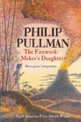  The Firework Maker's Daughter  Philip Pullman
Theme/Term | Disaster, hope & healing Spring 1 |  |  |  |  |  |  |  |  |  | Natural World Spring 2
Planning Sequence/  Spelling Seed Text | 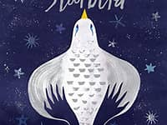 The Starbird By Carol King Chai |  | 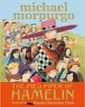  The Pied Piper of Hamelin Michael Morpurgo. |  |  |  |  |  |  |  | 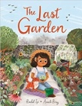  The Last Garden  Rachel Ip |  |  |  |  | 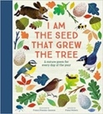  Poetry: I am the Seed that grew the Tree By Fiona Waters
Literary Leaf Text | 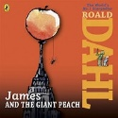James and The Giant Peach: Roald Dahl |  |  |  |  |  |  |  |  |  | 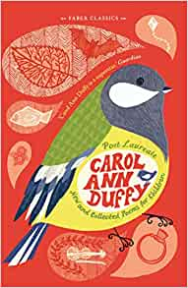  New and Collected Poems for children by Carol Ann Duffy
Theme/Term | From mystery to discovery Summer 1 |  |  |  |  |  |  |  |  |  | Confidence & caution Summer 2
Planning Sequence/  Spelling Seed Text | 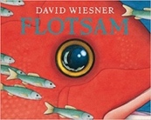  Flotsam  David Wiesner |  | 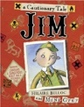  Jim, A Cautionary Tale By Hilaire Belloc |  |  |  |  |  |  |  | 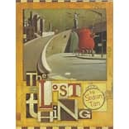 The Lost Thing By Shaun Tann |  |  |  |  |  | 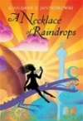  A Necklace of Raindrops By Joan Aiken
Literary Leaf Text | 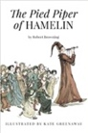  The Pied Piper of Hamelin  Robert Browning |  |  |  |  |  |  |  |  |  | A Necklace of Raindrops By Joan Aiken
Year 4 | Finding Freedom Autumn 1 |  |  |  |  |  |  |  |  |  | Invention & innovation Autumn 2
Planning Sequence/  Spelling Seed Text | 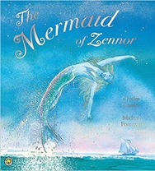  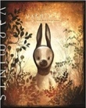  Varmints  Helen Ward |  | 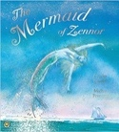  The Mermaid of Zennor  Charles Causley |  |  |  |  |  |  |  | The Iron Man  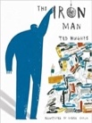  Ted Hughes | 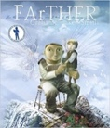  FArTHER  Grahame Baker Smith
Literary Leaf Text | 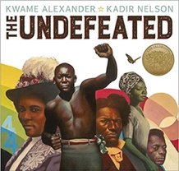  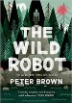  The Wild Robot By Peter Brown |  |  |  |  |  |  |  |  |  | The Iron Man  Ted Hughes
Theme/Term | Family andFriendship Spring 1 |  |  |  |  |  |  |  |  |  | Taking courage Spring 2
Planning Sequence/  Spelling Seed Text | 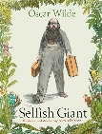The Sellfish Giant By Oscar Wilde |  | 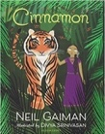  Cinnamon  Neil Gaiman |  |  |  |  |  |  | 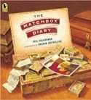  The Matchbox Diary  Paul Fleischman |  |  |  |  |  | 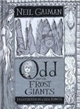  Odd and the Frost Giants  Neil Gaiman
Literary Leaf Text | The Sellfish Giant By Oscar Wilde |  | 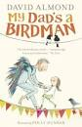David Almond My Dad’s a Birdman |  |  |  |  |  |  |  | Odd and the Frost Giants  Neil Gaiman
Theme/Term | Exploration & discovery Summer 1 |  |  |  |  |  |  |  |  |  | Different worlds Summer 2
Planning Sequence/  Spelling Seed Text | 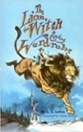  The Lion the Witch and the Wardrobe  C. S. Lewis |  | 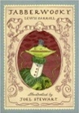  Poetry: Jabberwocky  Lewis Carroll |  |  |  |  |  |  |  | 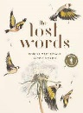 Poetry: The Lost Words By Robert Mc Farlane | 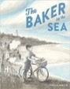 The Baker By The Sea By Paula White
Literary Leaf Text | The Lion the Witch and the Wardrobe  C. S. Lewis |  | Poetry: Jabberwocky  Lewis Carroll |  |  |  |  |  |  |  | 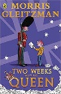 Two weeks with the Queen Morris Gleitzman

Year 5 | Exploration and Discovery Autumn 1 |  |  |  |  |  | Ambition & desire Autumn 2
Planning Sequence/  Spelling Seed Text | 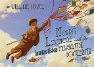The Fantastic Flying Books of Mr Morris Lessmore, WE Joyce | 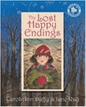  The Lost Happy Endings  Carol Ann Duffy |  |  |  |  | 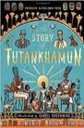  The Story of Tutankhamun  Patricia Cleveland-Peck |  |  |  | 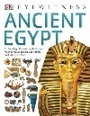 Dorling Kindersley: Ancient Egypt
Literary Leaf Text | 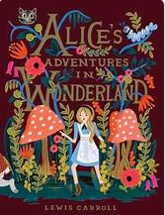Alice in Wonderland CS Lewis |  |  |  |  | 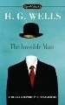The Invisible Man HG Wells | 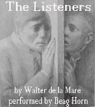The Listeners Walter De la Mare  Walter De La Mare
Theme/Term | Lessons from History Spring 1 |  |  |  |  |  | Exploration, suspense and adventure Spring 2
Planning Sequence/  Spelling Seed Text | Viking Boy Tony Bradman 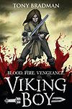 |  | Vikings By Dorling Kindersley 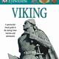 |  |  |  | Explorers By Katherine Rundell 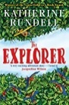 |  |  |  | 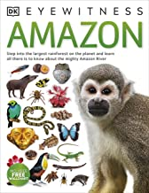Eyewitness: Amazon
Literary Leaf Text | Viking Boy Tony Bradman |  |  |  | 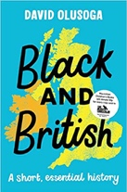  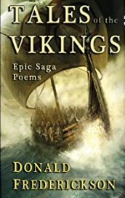Viking saga Poems by Donald Frederickson |  | Explorers By Katherine Rundell | 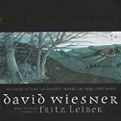 Gonna Roll the Bones David Weisner
Theme/Term | Lessons from history Summer 1 |  |  |  |  |  | Making Connections Summer 2
Planning Sequence/  Spelling Seed Text | 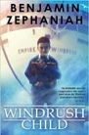  Windrush Child  Benjamin Zephaniah |  |  | 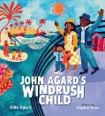 Poetry: Windrush Child By John Agard |  |  | 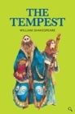  William Shakespeare The Tempest |  |  | 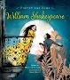 Poetry for Kids: William Shakespeare illustrated edition William Shakespeare
Literary Leaf Text | 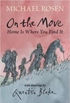  On the Move: Poems about Migration  Michael Rosen |  | 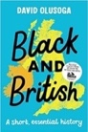  Black and British: A short, essential history  David Olusoga |  |  |  | William Shakespeare The Tempest |  | 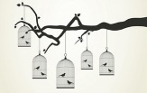 Caged Bird Maya Angelou | 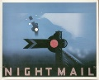 or Nightmail  WH Auden
Year 6 | Around the World Autumn 1 |  |  |  |  |  | Looking Back Autumn 2
Planning Sequence/  Spelling Seed Text | 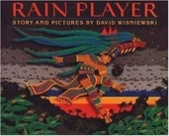  Rain Player David Wisniewski |  |  Day of the Dead Visual Literacy Literacy Shed |  |  |  | 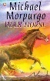War Horse Michael Morpurgo
Literary Leaf Text | 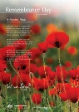 Flanders Field John McCrae |  |  |  |  |  | 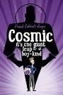Cosmic Frank Cottrell Boyce
Theme/Term | Crime and Punishment Spring 1 |  |  |  |  |  | Mystery and Wonder Spring 2
Planning Sequence/  Spelling Seed Text | 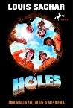Holes Louis Sachar |  |  |  | 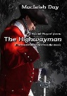The Highwayman Alfred Noyes |  | 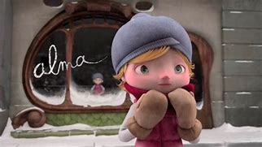Alma Literacy Shed |  |  |  | 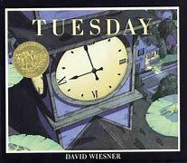Tuesday David Weisner
Literary Leaf Text | 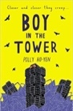  Boy in the Tower  Polly Ho-Yen |  |  |  |  |  | Recap and review of all domains, reflecting text coverage.
Theme/Term | Evolution Summer 1 |  |  |  |  |  | KS3 Transition Summer 2
Planning Sequence/  Spelling Seed Text | 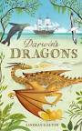Darwin’s Dragons By Lyndsey Galvin |  |  |  |  |  | 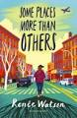Some paces more than others By Renee Watson
Literary Leaf Text | 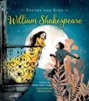  Poetry for Kids: William Shakespeare illustrated edition  William Shakespeare |  |  |  |  |  | Some paces more than others By Renee Watson

