Teaching through a text: Texts and writing genres Year 1 Overview
Autumn 1  Linked Learning: Journeys and exploration  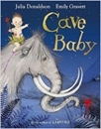  Cave Baby by Julia Donaldson & Emily Gravett  Labels and captions, character description. | Autumn 2  Linked Learning: Similarities and differences  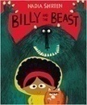  Billy and The Beast By Nadia Sharim  Wanted posters, narrative story writing.
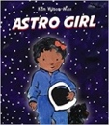  Astro Girl By Ken Wilson Max  Instructions, questions, non-fiction booklet. | 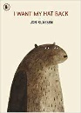  I want my Hat back By John Classon  Letter writing.
Story Time:
Traditional Tales- Little Red Riding Hood, Three Little Pigs, Gingerbread Man, The Three Billy Goats Gruff, including alternative versions (narratives from different viewpoints).

Spring 1  Linked Learning: Similarities and differences  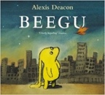  Beegu Alexis Deacon  Poetry, thought bubbles and speech bubbles. | Spring 2  Linked Learning: Nature and Environment  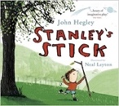  Stanley’s Stick By John Heagley and Neal Layton  Retellings and descriptions, own version narratives.
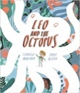  Leo and the Octopus By Isabelle Marionov  Factual descriptions, report. | 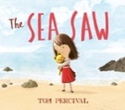  The Seesaw By Tom Percival  Diary entry recount.
Story Time:
Poetry- Space Poems
Roald Dahl – The Enormous Crocodile, Esio Trot.
Summer 1  Linked Learning: Friendship and kindness  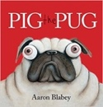  Pig the Pug by Aaron Blabey  How to guide (explanation), fact sheets,  Shared poetry. | Summer 2  Linked Learning: Imagination and creativity  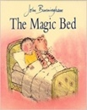  The Magic Bed John Burningham  Own version fantasy stories, setting descriptions, additional scenes, description of magical piece of furniture.
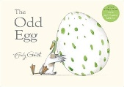  The Odd Egg By Emily Gravett  Egg spotters guides non-fiction reports, thoughts and speech bubbles. | 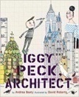  Iggy Peck Architect By Andrea Beatty and David Roberts  Character comparisons
Story Time:
The Tear Thief By Carol Ann Duffy & Cops and Robbers Janet and Alan Ahlberg

