Teaching through a text: Texts and writing genres Reception Overview
Autumn 1  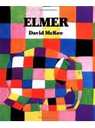Elmer David Mckee  The colour Monster Alan Lenas  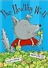The Healthy Wolf David Bedford  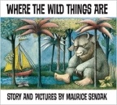  Where the Wild Things are By Maurice Sendak  Linked Learning: Difference | Autumn 2  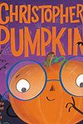Christopher Pumpkin Sue Hendra  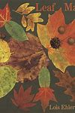Leaf man Lois Elhert  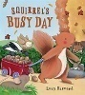Squirrel’s Busy Day by Lucy Barnard  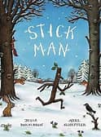Stick man Julia Donaldson  - The Nativity Story  - Divali Lighting a Lamp  - Remember, Remember the 5th of November Deborah Webb  Linked Learning: Celebrations & Autumnal Seasonal Changes
Spring 1  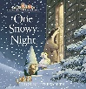One Snowy Night Nick Butterworth  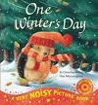One Winter’s Day Christina Butler  Lanterns and Firecrackers: a Chinese New Year Story  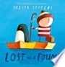Lost and Found Oliver Jeffers  The Great Pet Sale Nick Inkpen  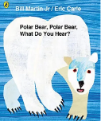Poetry- Polar Bear, Polar Bear what do you hear? Bill Martin  Linked Learning: celebrations, winter seasonal changes | Spring 2  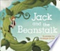Jack and the Beanstalk- anon  The Enormous Turnip  The Little Red Hen  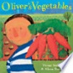Oliver’s Vegetables Alison Bartlett  A Seed In Need  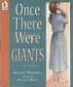Once there were Giants Martin Wardell  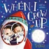When I grow Up John Hayles  Linked Learning: Spring seasonal changes, growth
Summer 1  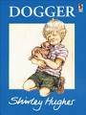Dogger Shirley Hughes  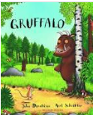Julia Donaldson – Author study:  The Gruffalo  The Smartest Giant in Town  A Squash and a Squeeze  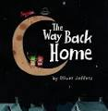The Way Back Home – Oliver Jeffers  Linked Learning: Toys in the past, Stories by the same author | Summer 2  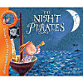The Night Pirates Peter Harris  Tiddler Julia Donaldson  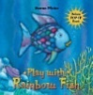The Rainbow Fish Marcus Pfister  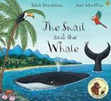The Snail and the Whale Julia Donaldson  The Life of a Little Plastic Bottle Igloo Books  Linked Learning: summer seasonal changes, environmental

